Chemistry Unit Review Sheet- Part 2

Read the descriptions below and determine whether each item describes an endothermic or an exothermic reaction.

_______________ 1. A reaction that produces heat energy
_______________ 2. A reaction that absorbs energy
_______________ 3. Paper burns
_______________ 4. Magnesium and Hydrogen peroxide react and the temperature increases
by 12°C
_______________ 5. Alka seltzer reacts with water and the temperature drops by 9°C

Identify the following reactions types as synthesis, decomposition, single displacement, or double displacement. Write the name beside each reaction.

11. 11H₂O + 12C C₁₂H₂₂O₁₁ _______________________
12. 2HgO 2Hg + O₂ _______________________
13. NaCl + HOH HCl + NaOH _______________________
14. Zn + H₂ SO₄ Zn SO₄ + H₂ _______________________

Determine whether the equations below are balanced or unbalanced.

15) H₂ + O₂ H₂ O₂ _______________________
16) Ag + O₂ Ag₂ O₂ _______________________
17) CdCO₃ CdO + CO₂ _______________________
18) KI + H₂ O₂ KOH + I₂ _______________________

NaOH + HCl NaCl + H₂ O + heat released

26) Is the equation balanced?

27) Label the reactant side and the product side of the reaction

28) What type of reaction it is—synthesis, decomposition, single displacement, double
Displacement

Write the vocabulary word in the blank beside its definition or clue.

________________ 29. You increase this by grinding or crushing a substance
________________ 30. These chemicals slow down reactions without altering the products
________________ 31. You increase this when you add more molecules of a chemical inside a
Set space
________________ 32. In order for a reaction to occur these must occur at proper angles
________________ 33. These chemicals speed up reactions without altering the products

Look at the equation below. The Law of Conservation says Matter and Energy can neither be created nor destroyed. So the total atoms of each element must be the same on both sides of the arrow. The arrow is an = sign in chemistry. The reactants are written on the left because you start the reaction with them. The products are on the right because they are produced in the reaction.
KI + H₂ O₂ KOH + I₂

12 grams + X = 15 grams + 9 grams
34. What is x? _________

35. Add coefficients to balance this equation.

37. The temperature rose during the reaction so it would an endo or exothermic reaction?

Fill in the Blank-- Use your notes to help you.
Word Bank- You may use more than once.
Reactants
exothermic
endothermic
heat
physical
energy
new
reaction
decrease
synthesis
decomposition
replacement
conservation
atoms
38. A chemical change is often referred to as a chemical _____________.
39. A chemical reaction involves the formation of a ____________ substance.
40. Chemical Reactions involve a change in ____________ properties and a change in __________.
41. Chemical reactions that release energy as ______ _ are called ____________ _ reactions.
42. Chemical reactions that absorb energy are called ___________________ _ reactions. You will observe a ___________ in temperature.
43. ___________________ are the ingredients that will react in a chemical reaction. The ______________________ are those things that are formed as a result of the reaction.
44. A ____________________ reaction is one where two elements combine to form a compound.
45. A ____________________ reaction is one where a compound decomposes into simplier substances.
46. (Need to use your notes) Evidence of a chemical reaction may include:
  - ________________
  - ________________
  - ________________
  - ________________

47. The Law of ____________________________________ of mass states that the mass of the products always equals the mass of the ____________ in a chemical reaction. In other words matter cannot be created or destroyed in a chemical reaction.
48. Why is it important to measure the mass of the products of a chemical reaction in a closed container?

49. When balancing chemical equations the number of ____________ must be equal on both sides of the equation.

Chemistry Review Sheet- Part 1
Matching:

Identify whether each is a: A) Physical Property B) Chemical Property
- Ability to burn
- Color
- Ability to tarnish
- Ability to freeze
- Ability to rust

Is it Chemical or Physical? A. chemical change B. physical change
- ___ Water freezes and becomes ice
- ___ HCl and Zn reacted. The Hydrogen gas collected in a balloon.
- ___ Sugar and Sulfuric acid mix to form a hot, black solid.
- ___ Ammonia and Copper pennies react to produce a dark substance called Copper Ammonium. The liquid color is now blue!
- ____ A copper roof will slowly change color when exposed to the elements.
- ____ A bike will rust in the presence of oxygen.
- ___You add sugar to hot water and it dissolves

Which family is which?
A. Carbon family b. Noble Gases C. Alkali metals D. Oxygen Family E.Halogens
- ___51) Sulfur is in this family
- ___52) Most reactive METALs; silvery white; form lots of compounds; explosive in water
- ___53) this family has silicon which is a metalloid used in making computer chips
- ___54) Most reactive NONMETALS on the periodic table; means salt producer; includes liquid, solids, & gases at room temperature
- ___55) inert family of elements; do not form compounds

Multiple Choice:
____18) What is composed of more than one element?
- Water b) Aluminum c) Carbon
___19) On the periodic table elements that are grouped by common chemical properties are called families or _____________
- Periods b) groups
___20) Elements are organized on the periodic table by increasing ______________number and ______________ was credited as father of the periodic table:
a)Mass number/ Lavoisier b) atomic number/ Mendeleev

___21) ___________ on the periodic table are based on how the electrons are arranged. For example in row 2 all of the elements have electrons spread into 2 levels.
- Periods b) groups
Substance | Density g/ml
Ice | 0.93
Corn syrup | 1.38
Mercury | 13.5

___22) Which substance would sink in the density column above?
- Ice b) Corn syrup c) Mercury d) corn syrup and mercury

23) LABEL THE COLUMN IN ORDER FROM least dense at the TOP to most dense at the bottom!
___24)If rubbing alcohol were added to the density column and it has a density of 0.94 g/ml where would it be?
- Between ice and corn syrup b) on top c) between corn syrup and mercury
Metals | Melting point ⁰C | Boiling point ⁰C
Iron | 1535 | 2750
Zinc | 419 | 907

___25) Room temperature is 25⁰C. Which elements are solids at room temperature?
- Iron b) zinc C) iron and zinc d) neither one
____26) At 450⁰C, which metal would be a liquid?
a) Iron b) zinc C) iron and zinc d) neither one

27) The majority of elements on the periodic table are _________________.
28) The _______________have properties of metals and nonmetals. Give one example:______________
29) Which two elements are in the same family? Oxygen and Selenium OR Magnesium and Sodium OR Copper and Boron

Fill in the chart below with missing information: #26-39
Element | Atomic number | Mass # (round to nearest whole number) | Protons | Electrons | neutrons
O | 8 | 16 | #30) | 8 | #31)
#28) | 6 | 12 | 6 | #32) | 6
S | 16 | #33) | 16 | 16 | 16
Mg | #34) | 24 | 12 | 12 | #35)
#36) | 19 | #37) | 19 | 19 | #38)
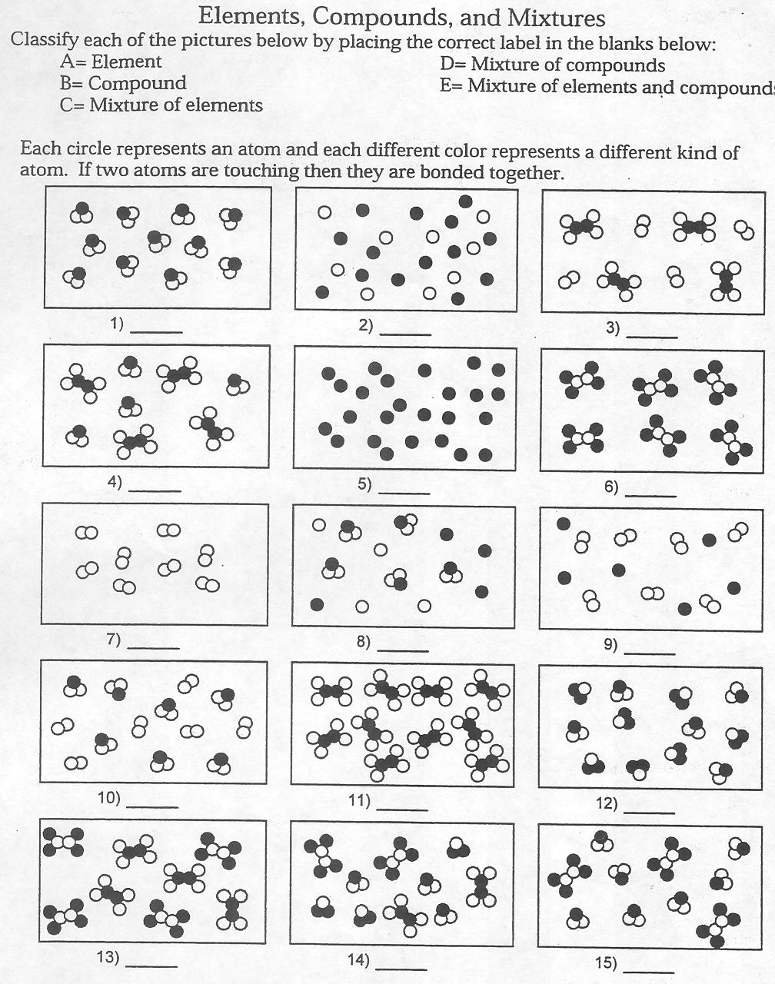
#39- 54 Identify each picture as an element, compound, or mixture.

