Vocabulary- Please define!
Antibiotic Resistant
Full Course
Annotate and complete the graphic organizer.
Have you ever taken antibiotics? Did you follow the directions completely? All antibiotics need to be taken as directed, which usually means taking all the pills and don't stopping even if you begin feeling better. Why?
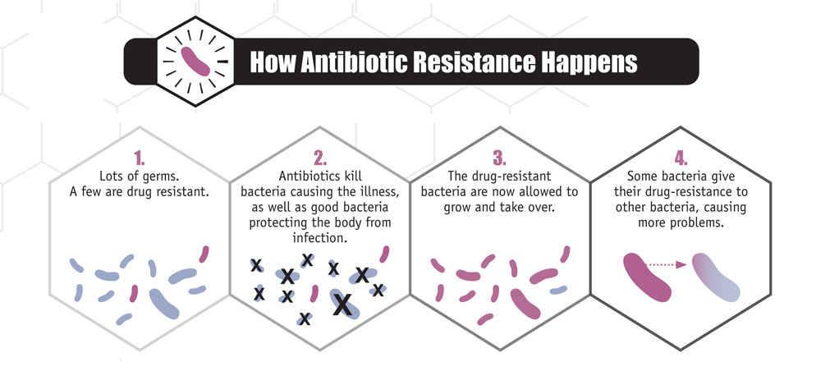
Millions of harmless bacteria naturally live on and inside of your body. When harmful bacteria appear on the scene, your body's immune system can usually keep a small population of them under control. If, however, these bacteria reproduce too quickly, you suffer consequences-- and this is called an infection. Antibiotics help your body fight off an infection by killing these harmful bacteria. Unfortunately, a small number of bacteria in any population may not be affected by the antibiotic as quickly. These bacteria, which are considered more resistant to the treatment, continue to reproduce and grow. Completing the full course of the antibiotic as prescribed helps make sure that these bacteria do not survive and therefore won't make you ill or infect anyone else.
Antibiotics have been used to fight disease for over 50 years. Today, they are using their effectiveness. This is the result of more antibiotic resistant bacteria. In the last 10- 15 year, antibiotic resistant bacteria have included strains of Mycobacterium tuberculosis, which causes tuberculosis (TB), and Streptococcus pnuemonae, the most common cause of human ear and sinus infections.
Reasons for the development of antibiotic- resistant bacteria include over prescription and incorrect use of antibiotics. "Using antibiotics incorrectly has led to the development of bacteria that can resist them." says Dr. Richard Dietrich of Kaiser Permanente in Baltimore, Maryland. This means that the drugs people rely on to cure everything from strep throat to bacterial pneumonia may not work when they are taken.
Most antibiotics must be taken over a period of time. When patients feel better, they sometimes stop taking the medications and don't complete the full course of treatment. In such cases, antibiotic-resistant bacteria may not be killed by the medication. They are more likely to reproduce and grow without competition from other microbes that have been killed by the drug. If the antibiotic- resistant bacteria could cause disease, it becomes difficult to treat the patient with antibiotics
"The bacteria that cause pneumonia and ear and sinus infections commonly live in our throats and noses," Dr. Dietrich says. "If you take an antibiotic for no good reason, it kills only the germs that are not resistant to the antibiotic. An infection caused be the remaining resistant bacteria can be very hard to treat." If you take antibiotics when you don't need them, the drugs may lose their ability to help you get better when you really do need them.
One reason antibiotics are overused is that so many patients ask for them. Dr. Dietrich adds that its common for patients to believe that antibiotics will cure whatever illness they have. But antibiotics work against only certain microbes, such as bacteria. They so not work against viruses. Doctors also used to prescribe antibiotics more often, partly as a precaution against disease. Now, this is less common and antibiotics are prescribed only for specific diseases.
Adapted with permission from Kaiser Permanente, 2001

Antibiotics

Prereading
What is antibiotic resistance?

Read, annotate and complete the post reading questions.

Deadly lung disease TB is hard to cure in India, putting the world at risk
By Scientific American, adapted by Newsela staff
MUMBAI, India — On a recent Monday afternoon, a crowd of patients gathered in a hallway at Mumbai's Hinduja Hospital. All were waiting to see Dr. Zarir Udwadia, an expert on lung diseases.
Many of the patients, like 19-year-old Nisha, have tuberculosis (TB). Nisha had already been treated elsewhere for more than a year. Then she learned that treatment errors had made the disease worse rather than curing it.
“My doctors kept on changing the drugs,” says Nisha.
By exposing Nisha's TB to various drugs without wiping it out, her doctors just made it stronger. Eventually, her disease became extremely resistant to a range of drugs.

A Doctor Spots India's Crisis
Udwadia is the doctor who first identified the problem of extreme drug resistance in TB bacteria in India. He and other health experts say that problem is becoming increasingly widespread in India. The country has too few laboratories, too many poorly trained health workers and thousands of infected people living in crowded unsanitary conditions. All this has made India home to the world's largest outbreak of drug-resistant TB.
More than 2 million Indians get the highly contagious disease every year, and a patient dies every two minutes. Around 62,000 of these people harbor TB that is resistant to at least four types of drugs. As many as 15,000 may have an even more dangerous type of the disease called "extremely drug-resistant TB" (XDR TB) that fights off almost every antibiotic doctors use to treat it.
Now difficult-to-kill TB is no longer just India's nightmare. In June, U.S. health authorities confirmed that an Indian patient with XDR TB had visited Chicago, Tennessee and Missouri. Health officials in several states are tracking down everyone with whom the patient had prolonged contact.

TB Versus Drugs
Tuberculosis typically attacks the lungs. It can be transmitted from person to person via coughing. The typical symptoms of a TB lung infection include fever, night sweats and a hacking cough.
Ordinary infections are cured through a mix of antibiotics. However, if the patient fails to complete the treatment or the TB bacteria are already resistant to one of the antibiotics, then some of the bacteria will survive, adapt and grow stronger. Some of the hardier bacteria that survive pass on drug-resistant traits to their offspring. Overtime, those traits then spread to a wider group of their descendants.
There are varying degrees of drug resistance. Some TB is resistant to only one of the drugs commonly used to treat the disease. Multidrug-resistant TB (MDR TB) does not respond to the two most powerful drugs, isoniazid and rifampicin. Finally, XDR TB is resistant to those two drugs and many others as well.

Not Enough Medical Equipment
In Nisha’s case, her doctors never tested her for drug resistance. She underwent treatment for more than a year with drugs that were doomed to fail. As a result, her infection only grew stronger.
What concerns TB experts like Udwadia is that India has been creating thousands of Nishas this way.
The Indian government has begun to spend much more money on its national tuberculosis control program. Government-run hospitals are now using new GeneXpert machines that can identify drug-resistant strains of TB. These machines let doctors detect resistance within two hours, rather than weeks.
However, there are still only 120 GeneXpert machines nationwide — not enough to test all patients suspected to have MDR TB. The machines are also expensive to use .As a result, most hospitals conduct GeneXpert tests only on patients who have failed to respond to the first two months of standard treatment.
Udwadia and other physicians voice a bigger concern. The GeneXpert test can spot resistance only to rifampicin, they note. India does not have enough laboratories to conduct further drug-resistance tests, so all patients flagged by the machines are immediately put on the same treatment course, one recommended for MDR TB.
Yet this one-size-fits-all treatment does not account for additional cases of stronger drug resistance that have already spread in Mumbai. Udwadia estimates such treatment would now cure only a third of the drug-resistant patients in the city. The rest would receive three or more useless drugs and their TB would become even more resistant.

When TB Hops A Plane
At this point, it is not clear how big the resistance problem is. If there are indeed many people with drug-resistant TB, it increases the chances of the disease spreading to the rest of the world. Nearly 1 million Indians traveled to the United States in 2014 alone.
Dr. Neil Schluger, an American TB expert, said the United States has the ability to deal with an outbreak, should one occur. Still, the worldwide migration of drug-resistant strains worries him.
"Potentially it is a huge public health problem,” Schluger said, though it would probably develop very slowly.
In India, the troubling situation is not without hope. Udwadia has found that some XDR-TB strains can be successfully treated with a combination of powerful drugs.
Even patients with a highly drug-resistant strain of TB have some chance of beating the disease, Udwadia said.

Post Reading Questions
According to the article, what circumstances led to the outbreak of drug-resistant TB in India?

Which paragraph from the introduction [paragraphs 1-4] BEST illustrates how TB can become drug-resistant?

Objective: Model the importance of taking a full course of antibiotics to prevent antibiotic resistance.
Procedures .
1. Place 20 beads into a cup representing the bacteria in your body causing disease. You should have 13 blue, 6 yellow, and 1 red.
2. Read the directions on the card in the bag.
3. Important: After each turn you must put one bead of each color remaining to cup to represent the continuing growth of the bacteria.
4. Record the number of bacteria during each turn.
Data
Day/ Turn | Blue Bead | Yellow beads | Red beads | Total number of beads
0
1
2
3
4
5
6
7
8
9
10

1. Graphing. Create a line graph representing the number of each bacteria (beads) over time (day). You will need to make a separate line for each type of bacteria (color of bead).
2. Did the antibiotic help you to completely kill all of the harmful bacteria living in your body? Explain.

3. Imagine infecting someone else immediately after catching the infection (before taking antibiotics). With what type of bacteria are you more likely to infect them?

4. Imagine infecting someone else near the end of your infection. With what type of bacteria would you most likely infect them with?

5. Your friend is prescribed antibiotics on Monday. Suppose she feels better two days later. Should she stop taking the medicine? Explain.

Title:
Number of Bacteria/ beads
Days

