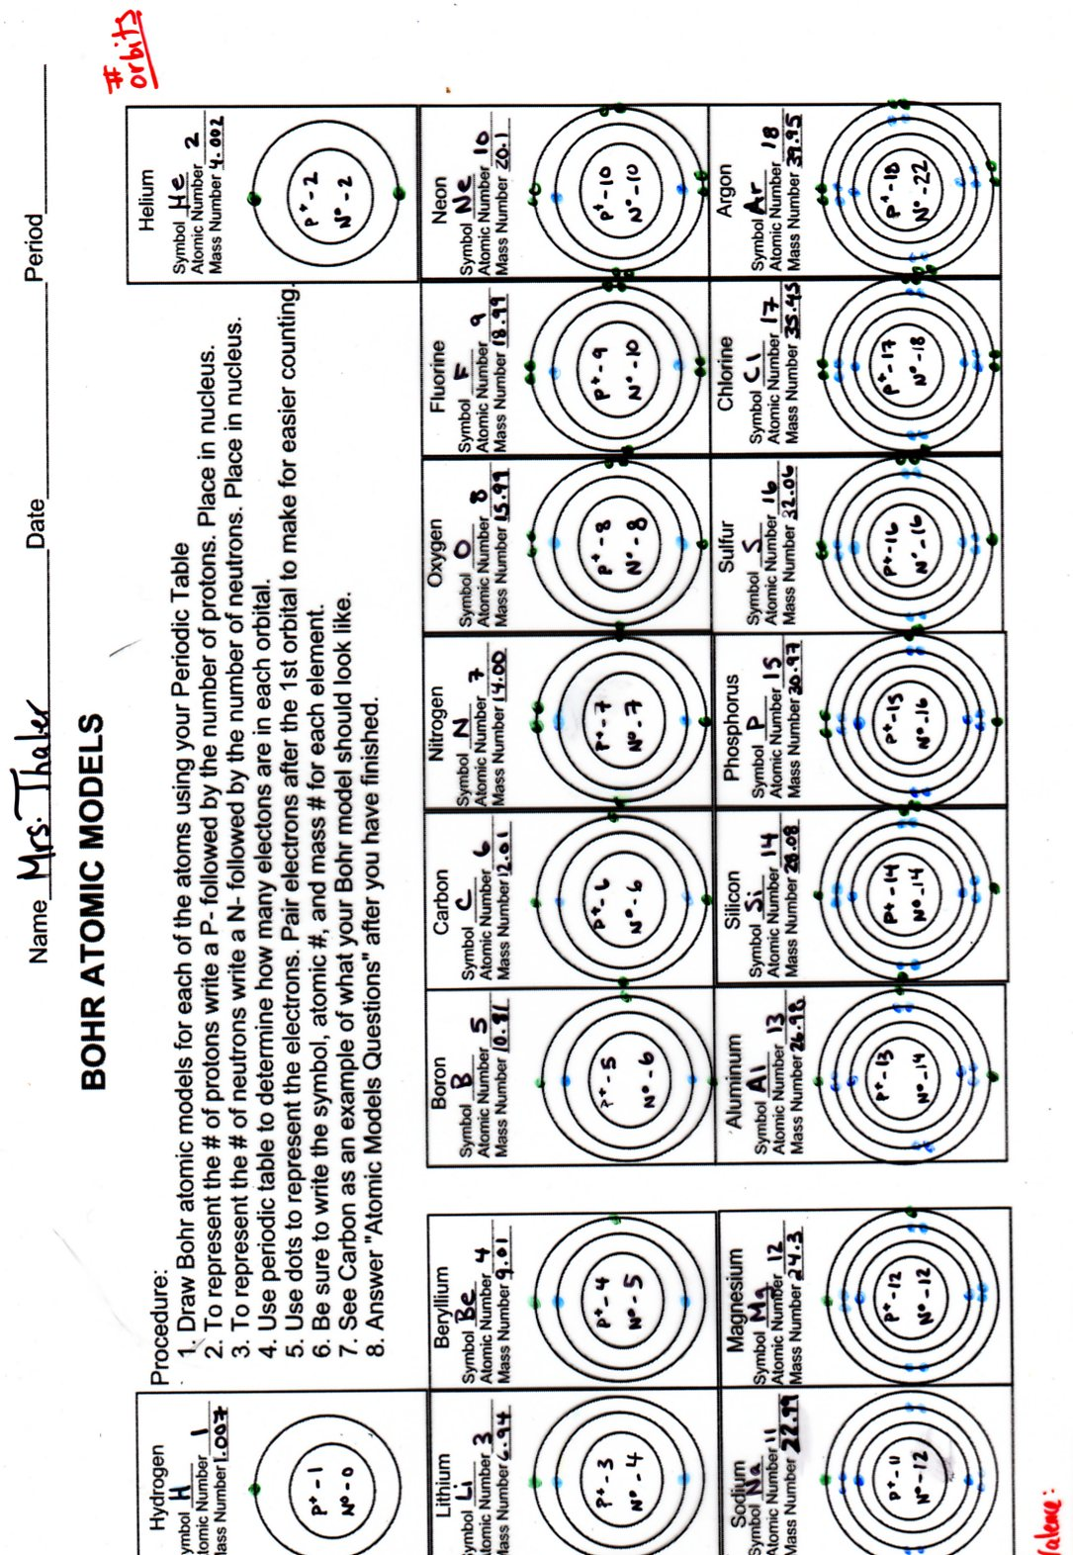
Bohr Model Questions
- What part of the periodic table tells you the number of protons in the nucleus of the atom of that element?

- By using the periodic table how did you determine how many neutrons are in the atom of an element?

- How many electrons are needed to fill the first shell or energy level?
  - The second energy level?
  - The third energy level?

- What are valence electrons?

- What is the importance of 8 valence electrons? (See notes on front.)

- Which atoms only need two valence electrons to have a filled outer shell?

- What do all noble gases have in common?

- What is in common between all the elements in the same column in the periodic table?
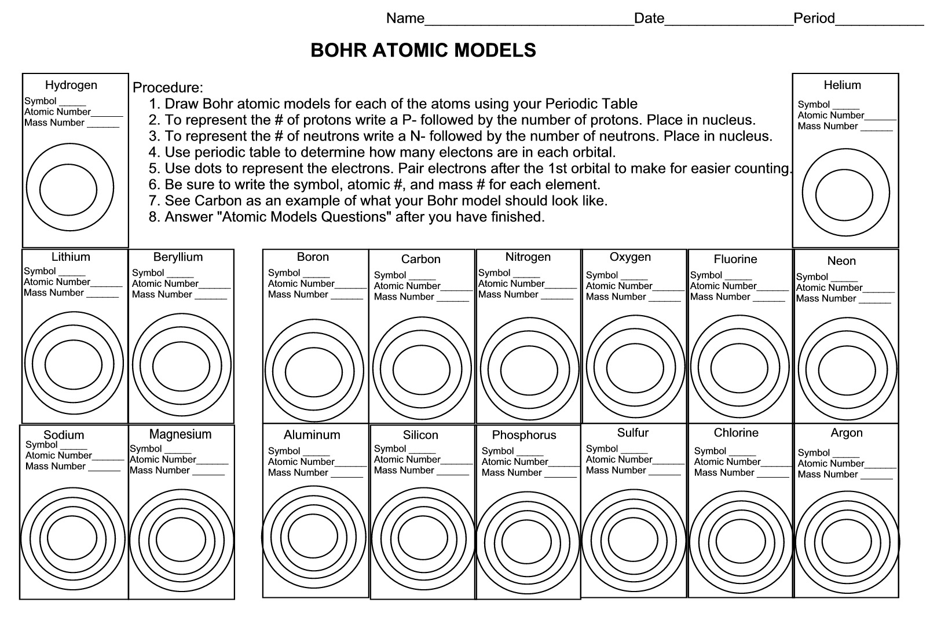
1. Create a Bohr Model of each of the elements.
2. Label the protons, neutrons and electrons.
3. T represent the # of protons write a P- followed by the number of protons. Place in the nucleus.
4. To represent the number of neutrons write N- followed by the number of neutrons. Place in the nucleus.
5. Use dots to represent the electrons. Pair electrons after the first shell to make counting easier.
6. Valence electrons are electrons in the out shell of an atom. They help to determine an elements ability to react or reactivity. The Octet rule says elements are stable or “happy” if they have eight valence electrons. Do you notice a pattern as you go across the period?
7. Answer the Bohr model questions.

