**BASIC ECOLOGY NOTES PPT WORKSHEET**

What is ecology?

_____________ - the scientific________ of _______________ between _____________and their______________, focusing on _________transfer

* It is a science of________________.

What do you mean by environment?

The environment is made up of _____ factors:

* **_________ factors**- all ___________ organisms inhabiting the Earth
* **__________ factors**- ____________ parts of the environment (i.e.______________, soil, _________, moisture, _____ currents)

*

*

*

**Habitat vs. Niche**

**_________**- the ________ a species plays in a community (job)

**____________**- the _________ in which an organism __________ out its life (address)

A __________is determined by the _____________ _____________of an organism, or a____________ __________.

**_____________ factor**- any biotic or abiotic factor that _________ the ____________of organisms in a specific environment.

Examples of limiting factors-

* + - Amount of _________
    - Amount of _________
    - _______________________

**Feeding Relationships**

* There are ___ main types of feeding relationships

1. ____________- _____________

2. ___________- _______

3. ___________- _______

___________- all _____________ (plants), they trap __________ from the ______

* __________ of the food chain

_____________- all________________: they ________ _______ containing the sun’s energy

* _____________
* Carnivores
* ________________
* Decomposers

Herbivores

* + Eat __________
* ______________ consumers
* ________ animals

Carnivores

* Eat ________
* ____________
  + ________ prey animals for food.
* _______________
  + Feed on ___________, dead animals

Omnivores

* Eat _______ plants and animals

Decomposers

* + - _______________ the complex compounds of ______and decaying plants and animals into simpler _____________ that can be ______________

**_____________**- ____________ to _______ species

**Trophic Levels**

* Each ______ in a food ________is known as a _________ level.
* Trophic levels ___________ a feeding ______ in the _________ of _________ and matter in an ecosystem.

**____________**- the _________ of __________ matter comprising a group of organisms in a habitat.

* As you move ___ a food chain, both available _________ & _________ ____________.
* _________ is transferred upwards but is _____________ with each transfer by ____________.

**________ chain**- __________ model that shows how matter and __________ move through an ecosystem

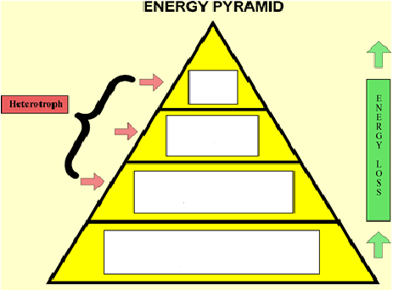



**Food ______**- shows ____ possible feeding ______________ in a community at each _________ level

* Represents a ____________ of interconnected food _________ .

**Food chain-** just ___ path of energy

**Food web-** ____ possible energy paths

Draw a sample food chain that you might see in North Carolina: include a producer, a primary consumer, a secondary consumer, and a tertiary consumer

_____________ _____________ ______________ _____________

**A sample food web of a salt marsh.**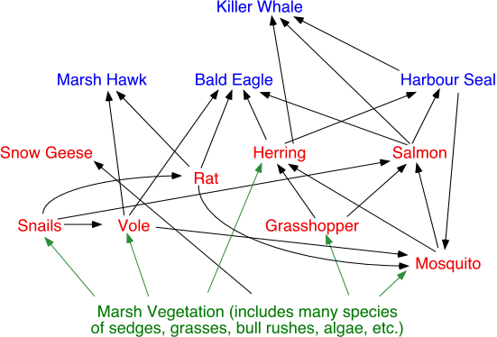

Using the following food web identify one food chain. Then identify the organism that are producers, primary consumer, secondary consumer, tertiary consumer, etc.

_____________ _____________ ______________ _____________

Using the sample food web identify all the animals in each trophic level. Some organism may be in more than one level.

