Fill in the blanks as we review the ppt. Write marginal notes as necessary.
- Types of Graphs
  - _______________ _______________: Show comparisons between collected data. The x and y data do not have to be numbers.
  - ________________________: Show intervals between collected data. Both the x and y DO have to be numbers.
  - ____________________ ___________________: Show ratios of parts to the whole. The data has been converted into percentages.
  - _______________________ _______________________: Show how the dependent(y) variable changes in response to the independent(x) variable.
  - _________________________ _____________________: Show a relationship between quantitative data collected in an experiment.
- Relationship between data:
  - __________________________________ correlation: show that as one data set increases the other also increases (up & up)
  - __________________________________ correlation: show that as one data set increases the other decreases. (up & down)
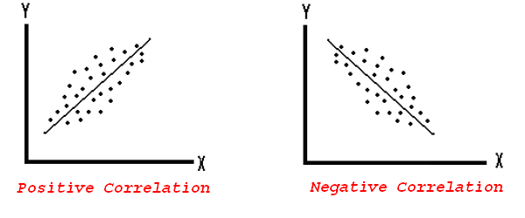
  - A ___________________ _______________ ______________ ___________ emphasizes the overall trend of the data as a whole.

- Parts of a Graph (THIS IS YOUR CHECKLIST TO MAKE SURE YOUR GRAPH IS COMPLETE)
  - _____________________________________ axis is for the x coordinates
  - _____________________________________ axis is for y coordinates
  - Origin is the point where the X and Y axes cross
  - X axis is the ___________________________________ variable
  - Y axis is the ___________________________________ variable
  - All axes should be labeled including the ___________________ ________________ __________________________________________.
  - All graphs should have a title. ( Dependent vs. Independent)
  - All graphs need equally spaced intervals called a _____________________________. Each axis may have a ___________________________________ scale.
  - Data points show the locations of a piece of data.
    - A coordinate is a pair of numbers used to determent the position of the point on a graph.
A line or curve of best fit shows the trend of the data on a scatter plot graph.
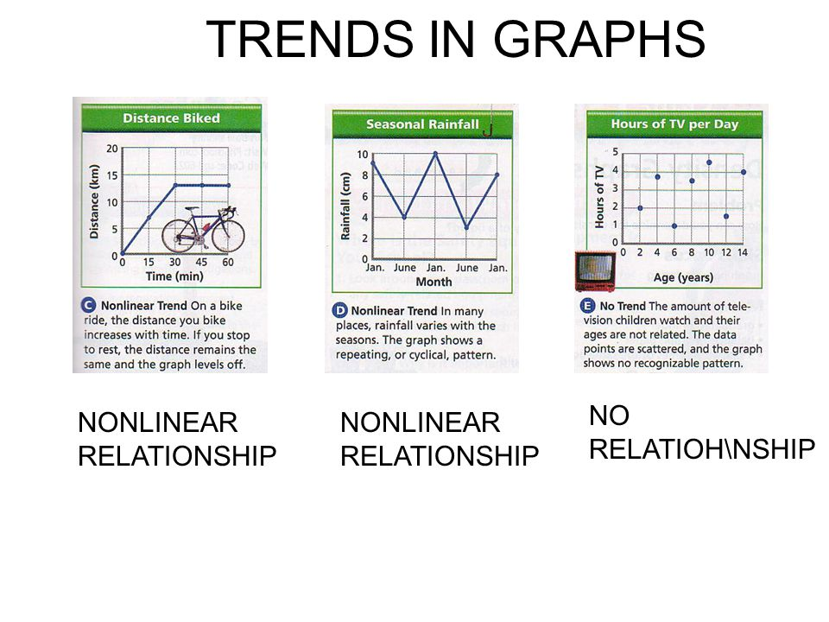

- Designing an Experiment
  - Scientists design experiments to explain ____________________ _______________ _____________________________________ relationships in nature.
  - These changing quantities are called _____________________________________. A variable is any factor that _____________________________. An experiment usually has three kinds of variables: independent, dependent, and controlled.
  - The ___________________________________________variable is the one that is __________________________________________ by the scientist. As the scientist changes the independent variable, he or she observes what happens.
  - The ________________________________________________ variable acts in ______________________________________________ to the independent variable. Ask yourself, which variable depends on the other one to happen? Does plant growth depend on light or Does the light depend on plant growth?
- The 5 steps of the Scientific Method:
- Make an Observation 2. Develop a Hypothesis 3. Make an experiment 4. Cary out the experiment and analyze the results 5. Draw conclusions
- Vocabulary:
________________________ __________________- Part of an experiment that serves as a basis of ______________________________________ to determine the effects of the variable (ex. Plants that don’t receive miracle-gro or receive regular sunlight)
___________________________________—Factors in the experiment that remain the _______________________________________ for all parts of the experiment (ex. Type of plant, type of soil, amount of light)
_________________________________ Group- The set up that contains the ___________________________________________________ variable. Usually a large sample is needed to make sure that results are correct (ex. For average height of 14 year old boys, measured 100 people is more accurate than measuring 10)
_______________________________________________ Variable- In the x-axis, the variable being acted upon (ex. changing the color of light)
_______________________________________ Variable- In the y axis, the variable that changes as a result of the independent variable. This is what you ____________________________________ and observe in the experiment (ex. The height of the plants)
________________________________-- _________________________- A well- supported hypothesis that has been tested many times, and has not been found to be incorrect (ex. Darwin’s theory of evolution by natural selection)

Example. Read the plans for the experiment below. What will be the independent variable, dependent variable, and control group? What variables should remain Constant?

Josh plans on building a greenhouse for his garden plants. He wants his tomato plants to grow well so decides on testing what color of glass he should use for his greenhouse. He buys four tomato plants approximately 20 cm in length. He plans to water each plant every two days for 30 days. He will give each plant a quarter cup of water each time he water them. He places each plant in a different color light. He will measure the height of each plant at the end of the week and record his data.

Independent Variable?

Dependent Variable?

Constants?

Control?

