SAS inquiry: Melting points and Boiling Points
Page ____
Purpose: In this activity we will examine the melting and boiling points of pure substances (elements from the periodic table or compounds). You will learn how to plot the points on a thermometer and to analyze the information the diagrams provide.
Table 1:
Substance | Melting point ºC | Boiling point ºC
Water | 0 | 100
Ethanol | -115 | 78
Bromine | -7 | 59
Radon | -71 | -61
- Take a pencil to draw a line for the melting points and boiling points for each substance.
- With a yellow colored pencil, color the area of the thermometer directly above the boiling point line.
- With a red colored pencil, color in the area between the boiling point and melting point lines.
- With a blue pencil, color in the area of the thermometer below the melting point line.
- Use arrows to help you label the MP and BP of each substance.
- In the yellow area, write GAS
- In the red area, write LIQUID
- In the blue area, write SOLID

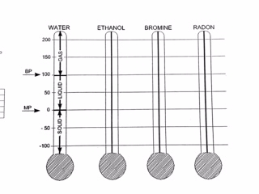
Name ______________________
Date_______________ pd________

Analysis of Changing States and the Constancy of melting and boiling points:
True or False:
- Water is always a liquid at 35⁰C ______________
- Bromine is a gas at – 60⁰C____________________
- Radon is a solid as 100 ⁰C____________________
- Bromine is a solid at 0⁰C ______________________
- Bromine melts at a lower temperature than ethanol____________
Short Answer:
- Which substance has the LOWEST boiling point?

- Which substance has the HIGHEST boiling point?

- Which substance has the LOWEST melting point?

- List the substances that are LIQUIDS at – 30⁰C.

- List the substances that are GASES at 70⁰C.

- List the substances that are SOLIDS at 10⁰C.

Lets Think!!!! Answer these after Part 2 is complete.

- What is the LOWEST temperature at which all FOUR substances will be gases?

- What is the HIGHEST temperature at which all FOUR substances will be solids?

- There are 100 degrees between water’s melting and boiling point. How many degrees are there between ETHANOL’s melting and boiling points?

- All pure substances change states at constant temperatures. When a pure substance like water, bromine, radon, and ethanol change from a liquid to a gas or solid to a liquid, are they becoming something NEW or just CHANGING FORM (or STATE)?

