Waves, Tides and Currents
- _________________________ are a movement of energy through a body of water.
- The size of a wave is determined by the strength of the ______________ and the length of ______________________________ it blows. The energy moves toward the shore but the water remains in place.
- Near the shore wave height increases and wavelength decreases as the wave’s energy runs out of seafloor. A ___________________________________ is a giant wave caused by an underwater earthquake. Waves shape a beach by erosion and deposition.
- The daily rise and fall of earth’s waters on its coastlines are called ________________________________. The interaction of gravity of the earth, moon, and sun cause the tides.
- The earth, moon, and sun change positions over the course of a lunar month thus affecting the tidal bulge in a month. A ______________________ ____________________ occurs when all three are in a horizontal alignment so the distance between high and low tide is at its greatest. A ____________________________ _____________ occurs when the sun, earth, and moon are at a right angle and there is the least difference between high and low tide.
- _______________________ __________________ affect water to a depth of several hundred meters. They are driven by the wind.
- Currents move in circular patterns due to the rotation of the Earth. It causes the winds and currents to curve. This is called the __________________ _____________
- The Gulf Stream in the Atlantic is the largest surface current carrying water from the Gulf of Mexico to the northeast. It warms the climate of many coastlines as it travels north. Ex.Norway is warmer than nearby countries due to the Gulf Stream
- Density differences in ocean water is due to salinity, temperature and depth of the water.
- _______________________ bring cold water to the surface in the open ocean. Along with the movement of water nutrients and food for fish are brought to the surface. Fish follow upwellings.
- El Nino is an abnormal climate event that occurs every 2-7 years in the Pacific. The unusual pattern of winds causes a large layer of warm water to move toward South America. It causes weather problems worldwide.
- ____________________ ________________ _______________ are caused by dense cold water that sinks to the bottom and moves toward the poles. It takes 1000s of years for the deep water currents to circle from pole to equator and back.
Ocean Chemistry:
- Ocean averages ______ to _______ parts salt to parts water.
- _____________ is defined as the total amount of dissolved salts in water.
- Seawater has a higher density than freshwater and freezes at a lower temperature.
- ____________________ water is a mix of fresh & ocean water. (not on handout- need to ADD)
- Surface water becomes diluted with freshwater after storms, rain, or where rivers dump into the sea.
- Salinity is also affected by ___________________ and ___________________ of the water.
- ________________________________are found in ocean water. The CO₂ and O₂ cycle occurs to supply dissolved oxygen to animals and CO₂ to plants in the ocean.
- Cold water contains _________________________ dissolved oxygen than warmer water.
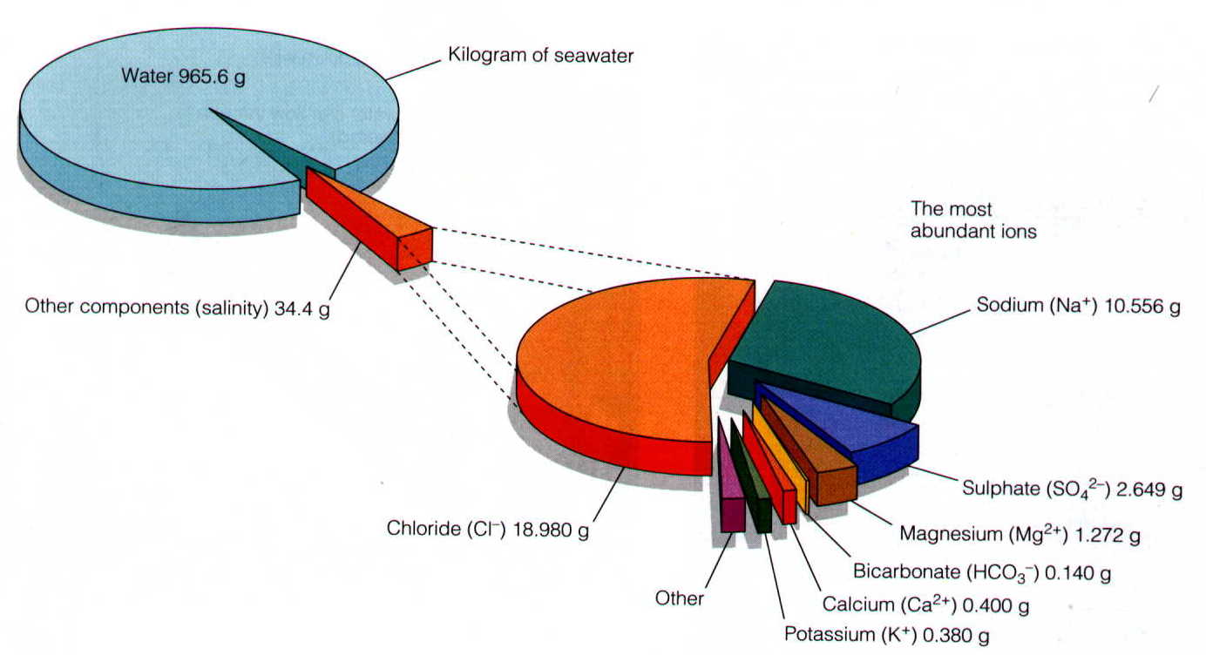
- Salts in the ocean NaCl, NaSO₄ , CaCl₂ , KCl, . . .

