Notes- Ecosystems and Energy Pg. __________
What are energy roles in an ecosystem?
- An _______________________________ is a community of organisms that live in a particular area, along with their nonliving environment. An ecosystem is a living system.
- In an ecosystem, an organism’s _______________________ role is determined by how it obtains food. Each _________________________ fills the role of producer, consumer or decomposer.
- A ___________________________ is an organism that can make its own food. Most producers make their food by using the sun’s energy in the process of photosynthesis.
- A __________________________is an organism that obtains energy by feeding on other organisms.
- A ___________________________ is an organism that obtains energy by breaking down once-living material, such as the bodies of dead organisms.
What is a food chain?
A __________________ _______________ is a series of events in which one organism eats another and obtains energy. The diagram below shows one food chain.
- The first organism in a food chain is always a __________________ such as algae or phytoplankton.
- The second organism, such as the flagfish, feeds on the producer and is called a ________________ __________________.
- A ____________ ________________, such as the largemouth bass, eats the primary consumer.
- A _________________consumer, such as the Anhinga, eats the secondary consumer.
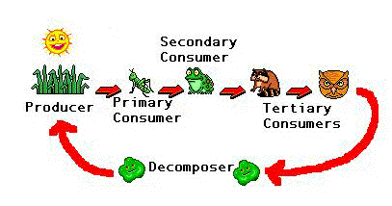
- In most food chains, the __________________ is the original source of energy. Producers capture the energy in photosynthesis and make food.
- In a food chain, energy flows from a producer to a primary consumer to secondary consumer to tertiary consumer. Food chains can also have a fourth-level consumers.
- A _________________ _______________ consists of many overlapping food chains in an ecosystem.
- An organism may play more than one role in a food web. For example, a first-level consumer may also be a second-level consumer, depending on its food sources.

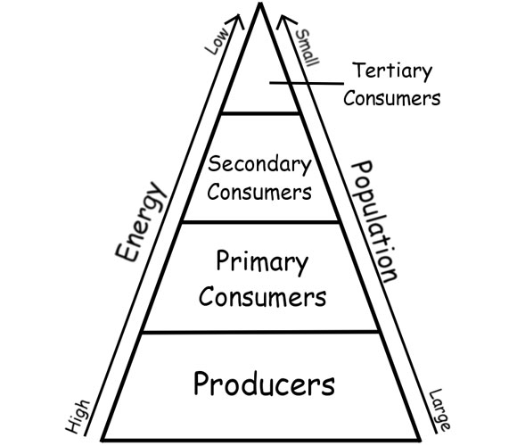
What is an energy pyramid?
- A diagram called an ____________ ____________ shows the amount of energy that moves from one feeding level to another in a food web. Energy is measured in kilocalories (kcal).
- Organisms use energy to perform life functions, such as ____________ and ________________. Only some of the energy an organism obtains will be available to the next organism in the food web.
- The most energy is available at the producer level of the pyramid.
- As you move up an energy pyramid, each level has less energy available than the level below.
