Freshwaters Distribution– PowerPoint Notes p. ____

What is your ecological address? ________________________________________

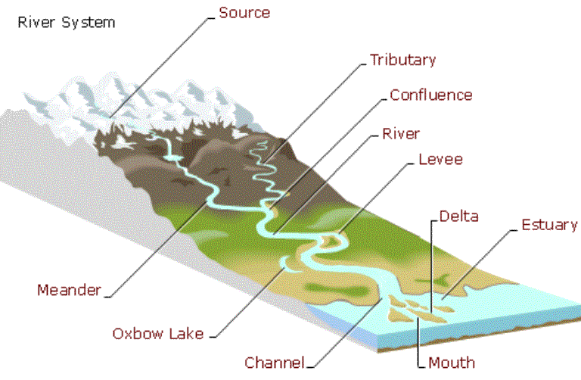
Part i: Fresh Water Locations—Rivers, Streams, and Lakes

What is a river?

A large ___________ along which water is continually flowing down a slope—made of ________ streams that come together called ___________________.

What is a stream?

A small __________ along which water is continually flowing down a slope—made of small ___________

What is a lake?

A body of water of considerable size ____________ on a body of land.
A _____________________is a man made or natural lake used for drinking water. Examples include ______________ Lake and ________________ Lake

Part ii: Fresh Water Locations—Surface Water
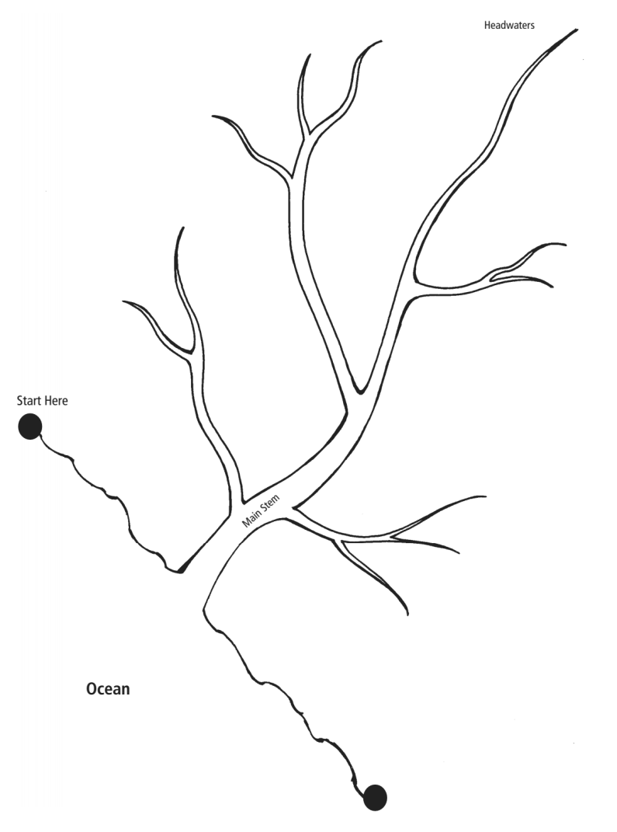

- What are the features of a River System?
A _________________ _ _______________ is made up of a larger river and the tributaries that run into it.
A ___________________is the land area that surrounds the river system and supplies water to the river system.
A ____________________ is a landform that separates two watersheds. (ex. Hills, mountains, etc.)

- What is the difference between a watershed and a river basin?

Both terms describe _______________ that drains into a river, stream or lake

River Basin: the term used to describe an area that drains into a large ________________________

___________________: the term used to describe an area that drains into
a ___________________________river or stream

Part iii. What is the difference between a river basin and a watershed?
Both terms describe land that drains into a river, stream or lake
    - _________________________ _________________: the term used to describe an area that drains into a large river
    - Watershed: the term used to describe an area that drains into a ______________________ river or stream
    - A _____________________________is a landform that separates two watersheds. (ex. Hills, mountains, etc.)

Part iv: Fresh Water Locations: River Basins and Watersheds

Larger river basins are made up of many ____________ _______________ watersheds

Example: Cape Fear and Neuse River Basins are made of many
_______________ watersheds

The water in a watershed runs to the__________ point—a river, stream, lake, or _______________.

Circle the Neuse River Basin. How many River Basins are there in North Carolina? ______
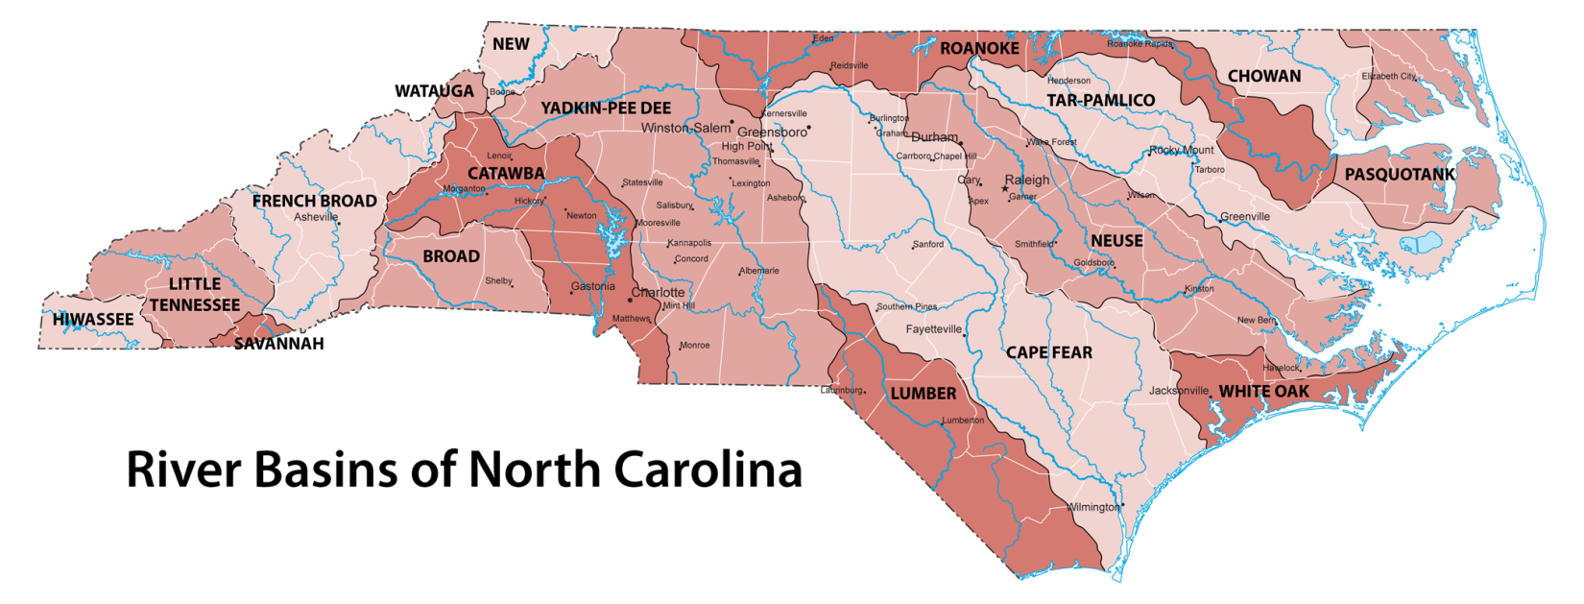

Part vi. Other Surface Water-
What is a wetland?
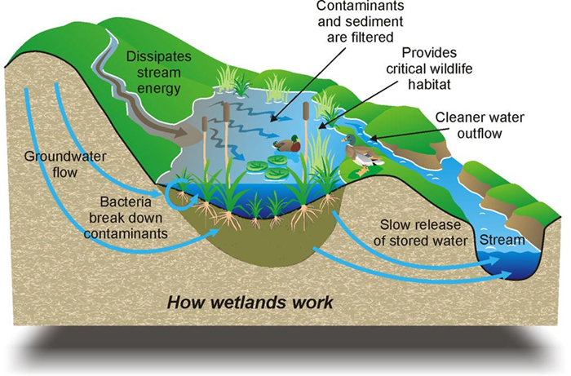
--An area where the water table is___________, _______________or above the land surface long enough during the year to support__________ plant growth. (______________plants and hydric soil) means WET with water . Wetlands are the most _________________ecosystems on earth. Wetlands are natural ___________________of water in the water cycle. (act like sponges)
What are the types of wetlands? Swamps, bogs, and marshes
Swamp: a wetland dominated by _________________ex. Great Dismal Swamp.
Bogs: a wetland dominated by ______________ex. NC Mountains
Marshes: a wetland dominated by ____________ex. Salt Marshes on NC Coast

Part vii. Surface and Groundwater Connection
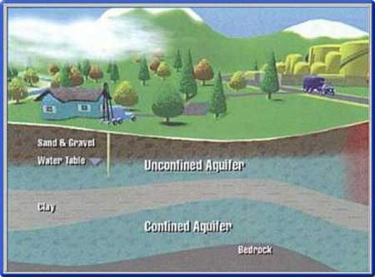
The water found in _____________ and ______________ in sand, gravel and rocks below the earth’s surface is considered _____________________________________.

Groundwater supplies almost ______________ of the water found in our rivers and streams and can often supply water to a stream in times of _______________________________.

Surface water can help to recharge ___________________________ as well.

Summary

Part iii: Fresh Water Locations—Rivers, Streams, and Lakes

What is a river?

A large ___________ along which water is continually flowing down a slope—made of ________ streams that come together called ___________________.

What is a stream?

A small __________ along which water is continually flowing down a slope—made of small ___________

What is a lake?

A body of water of considerable size ____________ on a body of land.
A _____________________is a man made or natural lake used for drinking water. Examples include ______________ Lake and ________________ Lake

The Surface and Groundwater Connection

- The water found in cracks and pores in sand, gravel, rocks below the Earth’s surface is considered __________________.
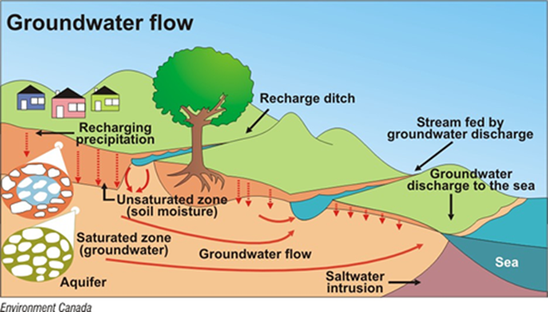
- Groundwater supplies almost _________________ of the water found in our rivers and streams and can often supply water to a stream in times of ______________________
Surface water can help to recharge ___________________________________ as well

