Notes- Evolution, Natural Selection, and Genetic Variation pg ________
Species and Species Variation
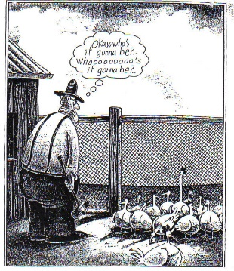
- Species- A group of ______________________ that are able to produce ____________________ that are healthy and capable of reproducing offspring.
  - Examples of different species:
    - Humans, blue whale, dogs, dogwood trees
    - Grey squirrels, white tail deer
- Genetic Variation- Not all organisms of the same ___________________ look or act alike. Example: humans have different eye, skin and hair color.
Charles Darwin and Natural Selection
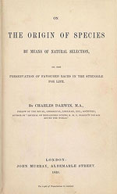
- Charles Darwin is a ______________________ who wrote the book On The Origins of Species in 1859 . The book presented evidence and proposed a mechanism for biological evolution called _________________ ___________________.
- Natural Selection- ___________________ ____________ is the gradual process by which certain _______________________ in a population become more common as a function of reproductive _________________.
The Theory of Evolution says…..
- Some organisms within a species are better ___________________ for certain ________________________________ than others.
- Organisms within a species that are not well suited for a certain environment will not survive. Aka “________________ ____________ _________ _____________”
- If all of the organism within a species are unable to _________________ to an environmental change, the species become __________________.

Notes- Evolution, Natural Selection, and Genetic Variation pg ________
Species and Species Variation
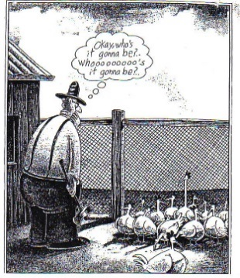
- Species- A group of ______________________ that are able to produce ____________________ that are healthy and capable of reproducing offspring.
  - Examples of different species:
    - Humans, blue whale, dogs, dogwood trees
    - Grey squirrels, white tail deer
- Genetic Variation- Not all organisms of the same ___________________ look or act alike. Example: humans have different eye, skin and hair color.
Charles Darwin and Natural Selection
- Charles Darwin is a ______________________ who wrote the book On The Origins of Species in 1859 . The book presented evidence and proposed a mechanism for biological evolution called _________________ ___________________.
- Natural Selection- ___________________ ____________ is the gradual process by which certain _______________________ in a population become more common as a function of reproductive _________________.
The Theory of Evolution says…..
- Some organisms within a species are better ___________________ for certain ________________________________ than others.
- Organisms within a species that are not well suited for a certain environment will not survive. Aka “________________ ____________ _________ _____________”
- If all of the organism within a species are unable to _________________ to an environmental change, the species become __________________.

