Ocean Current Worksheet

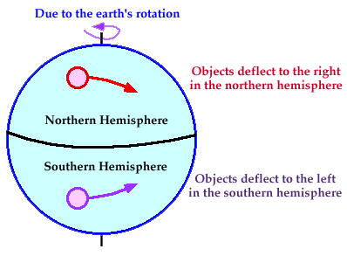
Temperature Affects and Surface Currents: Surface waters of the Earth’s oceans are forced to move, primarily by winds. Where winds blow in the same direction for a long period of time, currents will develop that transport large masses of water over considerable distances across ocean surfaces. Why do ocean currents and global winds move in a circular pattern? The circular pattern is caused by the Coriolis Effect. The Earth's rotation on its axis causes ocean currents and winds to curve to the right (clockwise direction) in the Northern Hemisphere and to the left (counter clockwise direction) in the Southern Hemisphere. As the winds and currents move, the Earth rotates underneath them. The currents appear to curve in relation to the Earth's surface. If the Earth did not spin on its axis then the currents and winds would appear to move in a straight direction.

Part I:
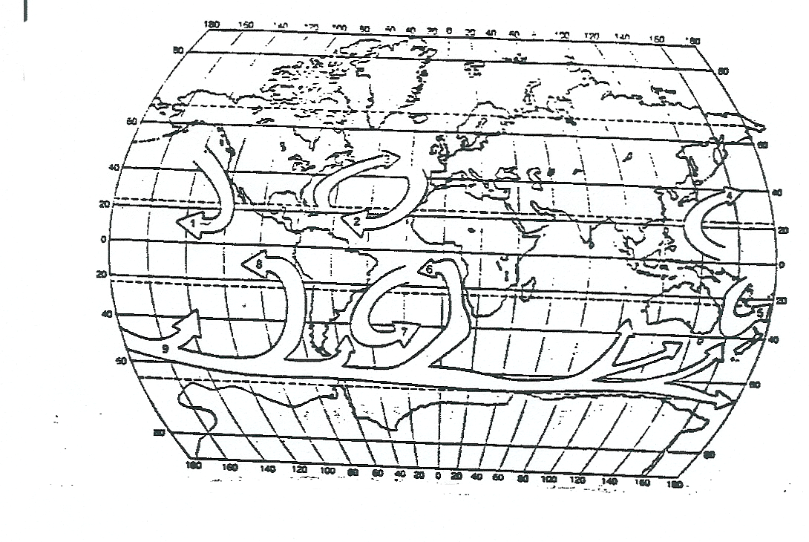
Using the table below label and color the currents in the picture (red = warm, blue = cold).
Number | Name of Surface Current | Characteristic Temperature of Water Transported by Current
1 | California Current | Cold
2 | Canary Current | Cold
3 | Gulf Stream | Warm
4 | Kuroshio Current | Warm
5 | East Australian Current | Warm
6 | Benguela Current | Cold
7 | Brazil Current | Warm
8 | Peru Current | Cold
9 | Antarctic Circumpolar Current | Cold

Questions:
- The ocean currents on your map generally travel in either a clockwise or counterclockwise direction. Look at the ocean currents and compare the general direction followed by currents in the Northern Hemisphere with the direction of those in the Southern Hemisphere.
  - In the Northern Hemisphere the general direction is _____________________.
  - In the Southern Hemisphere the general direction is _____________________.
- What happens to the direction of an ocean current when it approaches the coast of a large landmass?
- Cold water currents tend to have a cooling affect on the continental coastlines that they border, while warm water currents tend to have a warming effect. Look at the pattern of currents in the Northern and Southern hemispheres and describe the effect the currents have on the temperature of the coastal areas they border.
- The East coasts generally have ___________ (warm or cold) water currents.
- The West coasts generally have ___________ (warm or cold) water currents.
- The East coast climates will generally be _____________ (warmer or cooler) than it’s supposed to be.
- The West coast climates will generally be _____________ (warmer or cooler) than it’s supposed to be.
- Look at the pattern of cold and warm water currents. What seems to determine whether a current carries warm or cold water? Explain why this is so.

Currents and Upwellings
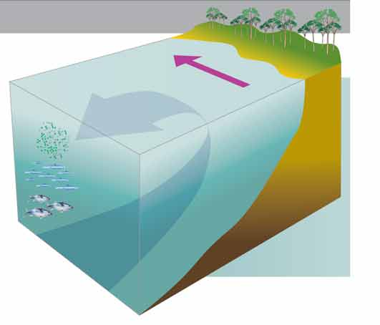
Upwelling occurs when surface waters diverge (move apart), enabling upward movement of water. Upwelling brings water to the surface that is enriched with nutrients important for primary productivity (algal growth) that in turn supports richly productive marine ecosystems.
Some of the most important upwelling regions are along the coasts of continents. In these coastal upwelling regions, surface winds push water away from the shore and create a divergence at the coast, which is replaced by water from depth. For coastal upwelling to occur, the wind must be parallel to the coast because water is deflected to the left of the wind in the southern hemisphere, and the right of the wind in the northern hemisphere. This deflection is due to the Coriolis force which causes objects travelling in a straight line appear to curve or deflect due to the rotation of the earth.
Upwelling regions are often measured by their productivity due to the influx of nutrients to the surface mixed layer and euphotic zone (sunlit layer) by upwelling currents. This drives photosynthesis of phytoplankton (tiny alga), which form the base of the ocean food web. Upwelling regions are less than 1 per cent of the world’s ocean by area, but account for greater than 20 percent of the global fish catch.

Most major upwelling regions are found along the west coasts of continents, such as off California, Peru, Namibia and South Africa. Large-scale upwelling off the west coast of Australia is suppressed due to the poleward-flowing Leeuwin Current. However, smaller-scale regional upwelling is found around the Australian coastline, including the largest and most predictable upwelling off the Bonney Coast in southeastern Australia.

- How does upwelling occur?

- Why do regions of upwelling have high productivity?

- Where are most upwelling regions located?

- How is the ocean’s food chain influenced by upwelling?

Questions

Answer Key:
Part I:
- Take a look at the two pictures above. What do you notice about the global wind and surface current patterns? In general, the direction of the wind flows in the same direction as the ocean surface currents.
- The global winds in the first map generally travel in either a clockwise or counterclockwise direction. Look at the global winds and compare the general direction of flow in the Northern Hemisphere with the general direction in the Southern Hemisphere.
  - In the Northern Hemisphere the general direction is clockwise.
  - In the Southern Hemisphere the general direction is counterclockwise.
- The difference in direction is caused by the coriolis effect.

Part II:
- The ocean currents on your map generally travel in either a clockwise or counterclockwise direction. Look at the ocean currents and compare the general direction followed by currents in the Northern Hemisphere with the direction of those in the Southern Hemisphere.
  - In the Northern Hemisphere the general direction is clockwise.
  - In the Southern Hemisphere the general direction is counterclockwise.
- What happens to the direction of an ocean current when it approaches the coast of a large landmass? It moves away.
- Cold water currents tend to have a cooling affect on the continental coastlines that they border, while warm water currents tend to have a warming effect. Look at the pattern of currents in the Northern and Southern hemispheres and describe the effect the currents have on the temperature of the coastal areas they border.
- The East coasts generally have warm (warm or cold) water currents.
- The West coasts generally have cold (warm or cold) water currents.
- The East coast climates will generally be warmer (warmer or cooler) than it’s supposed to be.
- The West coast climates will generally be cooler (warmer or cooler) than it’s supposed to be.
- Look at the pattern of cold and warm water currents. What seems to determine whether a current carries warm or cold water? Explain why this is so.
Warm water currents are carried from the equator to the poles. The sun’s rays are strike the Earth directly at the equator (they are more concentrated) and so, it warms up the water in this area. Cold water currents are carried from the poles to the equator. The sun’s rays strike the Earth at a low angle at the poles (they are spread out) and so, the water is cold in this area.

