What technology is used to study the oceans?
- As early as 600 B.C. the Phoenicians were exploring the ocean surface by _____________
- In 1000 the Chinese discovered the ______________ so navigating the ocean became easier
- 1825 _______________ gear was invented so man could spend more time under the water exploring
- 1920’s ________________ (sound navigation and ranging) was invented due to a need to detect submarines. Another application is to use sound waves to map the ________ _________.
- 1934- 1st ______________________ --Deep sea dive in a steel ball
Now: submersible vehicles with humans; remotely operated vehicles(ROV’s) from ship on the surface
- _______________ __________ is using ________________ or aircraft to gather data from afar. Then when the scientist go to the site to verify it is called _________________ ____________. Ex. Mapping ocean _________________ temperatures
Direct and Indirect observations- Classify each technology at your desk into these two groups.
Direct Observations-
Indirect Observations-
Seafloor Topography
  - _________________ ______________- gently sloping area of ocean floor that extends from the beach out to sea
  - _____________ _________-steep edge where the shelf drops off to deeper water
  - ____________ _________- flat regions in the deep ocean
  - ________ _________ _______-continuous range of volcanic mountains winding around the earth through the entire world’s ocean. It is nearly 80,000 k m long.
  - _______________- a volcanic mountain whose peak does not break the surface of the ocean.
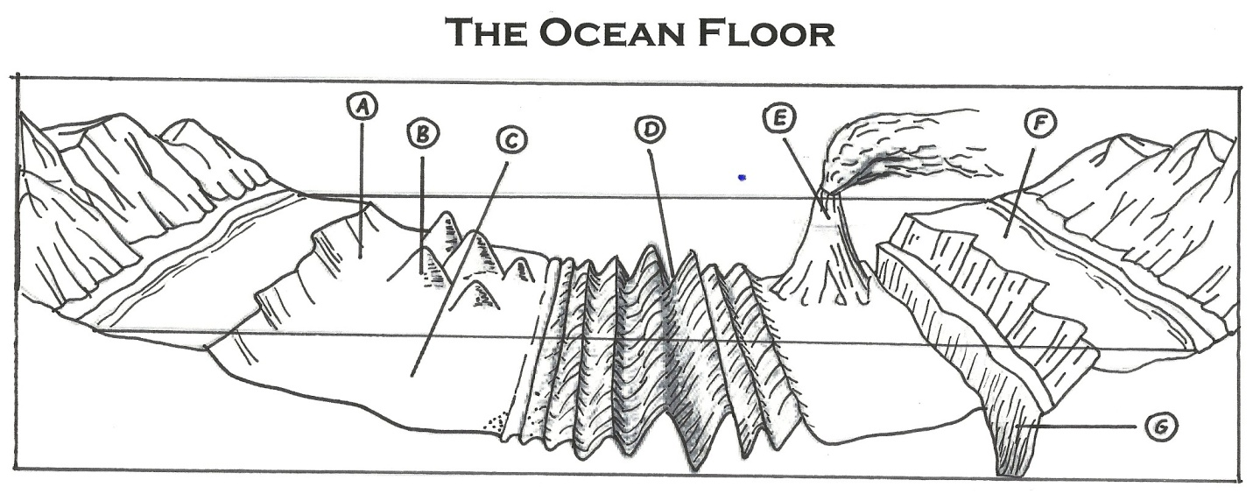
  - _________________– canyon deep on the ocean floor. The Mariana Trench in the Pacific Ocean is 11 km deep and the deepest point in the ocean
Ocean Habitats and Zones
- The ocean is a huge community of living and nonliving things. The habitat zones of the ocean are: Intertidal zone, Neretic zone, open ocean zone (Bathyl and Abyssal Zones).
___________ ______________ _________________ ______________
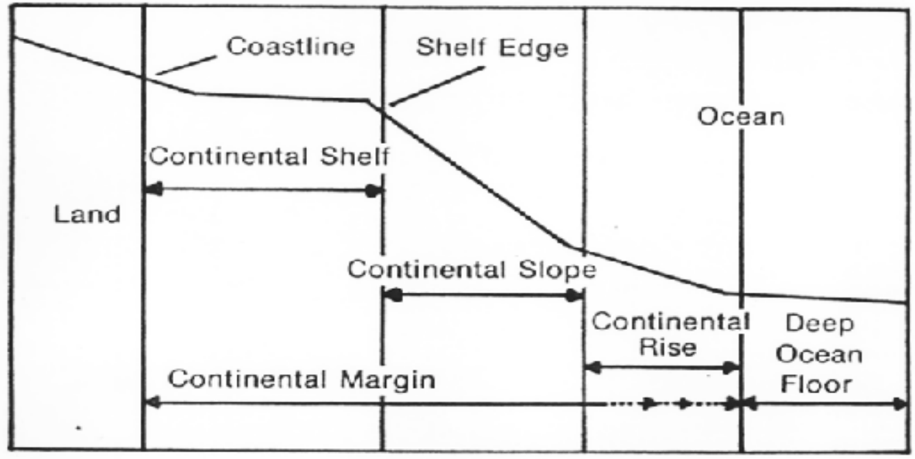
- Intertidal Zone
  - Organisms that live in this zone must be _______________ of changes in the environment.
  - Organisms must be able to withstand changes in __________________, ___________ and __________________ to air.

- Neretic Zone
  - It is home to a variety of _______________ organisms.
  - There is plenty of ____________ and _________________ in the water.
  - ________________ are washed from the land into the oceans from rivers and estuaries.
- Open Ocean
  - The Open Ocean contains few nutrients and a small amount of sunlight.
  - Algae/ phytoplankton in the surface zone is the main food supply for organisms.
  - Light and pressure

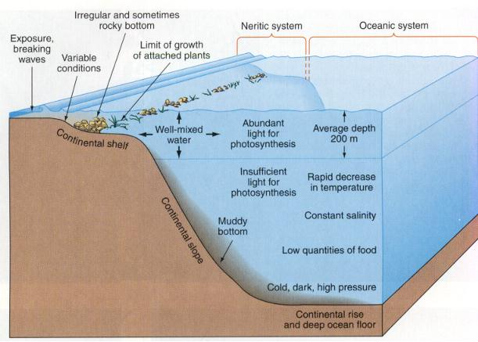
- In each zone, there are distinct physical factors such as the _________________________________________________________________________________________________ These factors determine which organisms live where. Organisms in the ocean are classified by where they live & how they move!
  - _____________ is the habitat zone of microscopic algae, krill, jellyfish, young crustaceans, and fish. These organisms float & move with the waves and currents. ________________ are algae, diatoms, . . (plants) and __________________ are animal.
  - ________________ are the classification of large fish, mammals, reptiles, . . . They are animals that can move freely throughout the ocean. Ex. Squid, whales, sharks, fish, seals, . .
  - ______________________ are animals that live on the seafloor. Some benthos move freely. Lobsters, sea stars, crabs would be an example. Some benthos are attached like sea anemones, corals, sponges.

