Background Information
Though both are considered to be disease outbreaks, a sudden increase in the number of persons with a disease, there are differences between them. An epidemic​ is an increase in the number of disease cases expected in an area, but is generally a more widespread situation than an outbreak. Though size of the area or region or numbers of disease are not the only factors when classifying an outbreak or epidemic, an epidemic generally has more disease cases over a larger region than an outbreak.
A pandemic ​is an epidemic that occurs over large areas such as entire countries or continents and affects a large proportion of the population. Pandemics have the potential to spread to multiple countries, especially in today’s ease of global transportation.
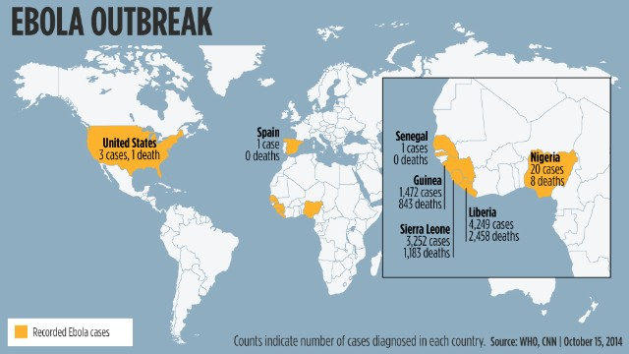
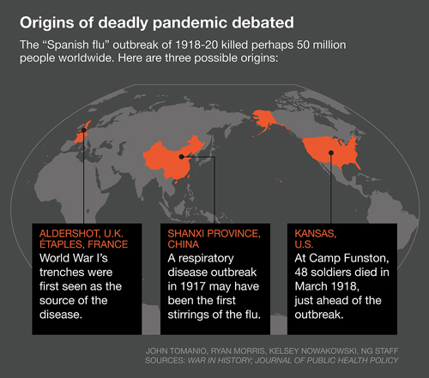
Use the maps to answer the questions.
- In 2014 Ebola, a rare and fatal disease, was seen as the worst outbreak of Ebola in history.
  - What countries saw cases of this disease?

  - Which country saw the most cases of Ebola?

  - How many deaths were contributed to Ebola worldwide?

  - How many more cases did Liberia have than Sierra Leone?

- Was Ebola an example of an epidemic or pandemic? Explain why or why not?

- The “Spanish Flu” was one of the largest outbreaks of Influenza in the world. It killed over 50 million people worldwide.
  - According to the map, which countries reported the first outbreaks of the “Spanish” Flu?

  - Why do you think this is an example of a pandemic?

- The current measles outbreak has become quite severe. Some may claim it to have reached epidemic status as it has infected many people across the US. How can this outbreak reach pandemic status?

