**Test date: 1_______________________**

__1) N.C. currently depends on petroleum-based fuels from other states. Scientists in the state are working to create liquid fuels from organic matter. Which statement most accurately describes the effect that locally-produced biofuels will have on N.C.’s economy?

1. They will cause the cost of all fuels to increase
2. They will eliminate jobs in energy production in N.C.
3. They will increase our dependence on fuels produced in other state, boosting N.C’s economy.
4. They will reduce our dependence on fuels produced in others states, boosting N.C.’s economy
5. .

___2) A student became ill on 3 occasions in the past year. Each time, he was prescribed the same antibiotic since he had the same illness. What will likely happened if the student becomes ill again and the same antibiotics are prescribed?

1. The antibiotics were effective before so they will work because bacteria never alter their DNA sequence
2. The antibiotics which were effective before may not work because bacteria undergo DNA mutations.
3. The student will not require the prescription because the antibiotic helped him build up immunity
4. The student will need to double the dosage of antibiotic to fight the same level of infection due to resistance.

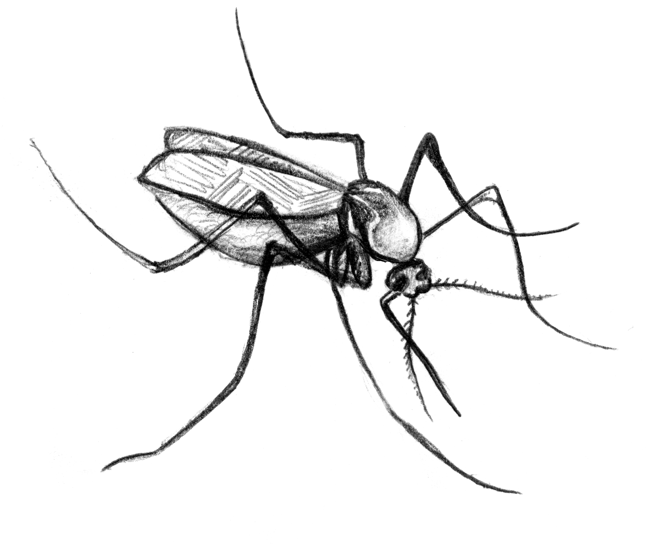___3) Use the diagram to choose the best answer to the question: What describes the role of the infected mosquito?

Infected mosquito ----🡪 bites and infects --🡪 uninfected human

C:\Documents and Settings\slancaster\Local Settings\Temporary Internet Files\Content.IE5\9B7QEUJX\MC900288972[1].wmf

1. Carrier B. mutagen C. parasite D. vector

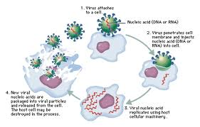___4) The diagram shows the steps involved in a viral infection: What happens as a result of the virus replicating inside the cell?

1. It multiplies and divides
2. IT is unaffected by the virus
3. IT copies its DNA and organelles
4. It is destroyed by the virus

___5) Luke is suffering from a case of athlete’s foot. Which treatment would best provide relief for his illness?

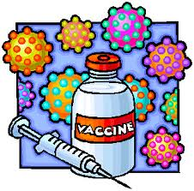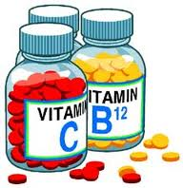

Antibiotic

1. B. C. D.

____6. The diseqa sterp trhoart

___6) The disease strep throat is caused by a **bacterial** infection. The infected person carries the **streptococcus** bacteria in the mouth and nasal fluid. Symptoms include a high fever, a sore throat, and a skin rash. Which action can spread the disease?

1. Washing hands properly with soap
2. Using a tissue for coughing and sneezing
3. Allowing an infected person to attend school
4. Keeping separate utensils for the infected person

___7) A student observed microbes under the microscope and sketched her observations. The drawings show the microbes she observed, as well as the magnification she used to view the specimens.

1. paramecium.bmpMicrobe 1 is nonliving and microbe 2 is living
2. Microbe 1 is much smaller than microbe 2
3. Microbe 1 is unicellular and Microbe 2 is multicellular
4. Both microbes are unicellular & photosynthetic

Microbe 1 Microbe 2

400 X 100 X

___8) What would occur if there were an unlimited nutrient supply

for bacteria?

1. Eventually the bacteria would consume all available nutrients and die out
2. The bacteria would quickly outcompete one another for resources and die out
3. The bacteria population would rise exponentially and their mass would could exceed the mass of the earth
4. The bacteria population would remain stable as they would die off as quickly as offspring were produced.

___9) Which situation could result in Lyme Disease?

1. A bite from an infected tick
2. A puncture would from a rusty nail
3. Inhalation of infected droplets
4. Consumption of contaminated food

___10) Scientists in N.C. are working to create liquid fuels from organic matter. What effect will this discovery most likely have on careers in the state?

1. It will eliminate jobs in waste management
2. It will reduce the number of engineering jobs
3. It will create jobs in energy production
4. It will create more jobs in the pharmaceutical industry

___13) Antibiotics are used to treat bacterial infections. Antibiotic X was added to a bacterial culture 3 hours after the bacteria began to grow. Which graph shows the typical effect of antibiotics on bacterial growth?

B.

A.

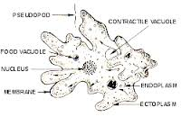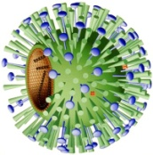___14) The diagram shows four different pathogenic microbe. Which microbe has both genetic material and a protein coat?

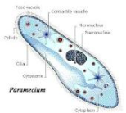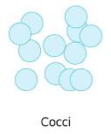

A B C D

___15) Which factor best explains why a virus will only infect certain cells?

1. **Viruses can only infect cells with a nucleus?**
2. **Viruses can only infect cells that lack certain genes**
3. **Viruses can only infect cells that are not in the process of dividing (mitosis**)
4. 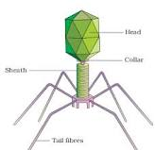Viruses can only attach to cells with the right surface proteins

___16) This diagram shows the common shape of one type of virus. Which structure on the bacteria host cell would come into contact with the area of the virus indicated by the arrow?

1. Cell wall B. Cytoplasm C.Nucleus D. Transport protein

___17) A group of friends attended a festival downtown where food was served. After the event, several individuals developed the same symptoms—nausea, vomiting, and stomach cramps. The table shows the foods eaten and the people who got sick.

|  |  |  |  |  |  |
| --- | --- | --- | --- | --- | --- |
| **People** | **BBQ sandwich** | **French fries** | **salad** | **soda** | **Got sick** |
| Javon | X | X | X | X | Yes |
| Ford |  | X | X | X | No |
| Emma | X | X |  |  | Yes |
| Teresa | X | x |  | X | Yes |
| Victor |  |  | X | x | No |
| Abril | x |  | x |  | yes |

Which explanation most likely describes how the people became sick?

1. Javon contracted the virus & spread it to the other individuals who also became sick
2. The BBQ sandwiches were improperly cooked and caused food poisoning
3. The salad was contaminated with the Salmonella bacteria
4. The sick individuals were exposed to a fast acting mutagen.

___25) A student scraped his knee while playing tennis. He noticed after 2 weeks his wound had nearly healed with just a small scar remaining. Which statement best explains the healing process?

1. The cells near the wound divided to form new cells
2. The cells from distant area s moved in to cover the injured part
3. The cells near the wound grew in size to cover the injured part
4. The cells released material that covered the wound and repaired the cells

___26) The number of mitochondria in an animal cell varies. Mitochondria are found in more active cells like liver and less in cells like hair. Which phrase best explains the role of mitochondria in active cells?

1. Remove waste products from the cell
2. Contain information to start cell division
3. Make high energy molecules for the cell to function
4. Control movement of material in and out of the cell

___27) What it the most likely consequence of increased cellular respiration?

1. More energy is available to the cell
2. Increased oxygen is released by the cell
3. Cell death
4. Decreased diffusion

___28) The table below shows the amount of bacteria present at several points as it divides. Which number most accurately predicts the amount of bacteria that would be counted at 80 minutes?

|  |  |
| --- | --- |
| Time | Number of bacteria |
| 0 min |  |
| 20 min |  |
| 40 min |  |
| 60 min |  |

1. 4 B. 8 C . 16 D. 32

___29) Ben became sick with the symptoms of a runny nose, sore throat, and fever. His doctor prescribed **antibiotics** to help him recover. What most likely caused Ben’s illness?

1. Bacteria B. fungi C. a mutagen D. virus

___30) What happens to a person’s body when an HIV infection occurs?

1. Immune cells are destroyed, making a person more susceptible to disease
2. Liver & Lung function are completely destroyed due to the viral infection
3. The body can no longer produce antibodies
4. The inflammation response is delayed and ineffective

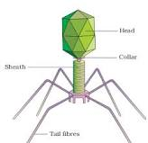___31) The diagram shows one common shape of a virus. What is the principle role of the structures indicated by the arrow?

1. Disease transmission B. viral movement C. to attach to a host cell D. to recognize a foreign virus

___32) The table has information about 4 diseases; Which term best describes the **cause** of the diseases listed?

|  |  |
| --- | --- |
| **Disease** | **Symptoms** |
| Food poisoning | Vomiting, cramps, diarrhea, fever |
| Strep throat | Sore throat, fever, swollen glands |
| Tetanus | Stiff jaw & neck, muscle spasms, difficulty swallowing |
| Lyme disease | Rash, chills, fever, body aches, swollen joints |

1. Bacteria B. carcinogens C. parasites D. viruses

___33) Which action would prevent the spread of an infectious disease?

1. Avoiding antibiotics B. prescribing antibiotics C. washing hands D. wearing sunscreen

___34) What is a primary limiting factor in bacterial growth?

1. Nutrients B. oxygen C. sunlight D. water

___35) If a person is suffering from a severe infection caused by bacteria, which solution might a doctor propose?

1. Antibiotics b. exercise C. surgery D. vaccination

___36) Students conducted a survey to study methods of disease prevention for colds. The results are in the bar graph. What conclusion does the data support

1. People who avoided touching their faces were the least likely to become ill
2. Handwashing is an effective way to prevent the spread of disease
3. Wearing gloves provides the same protection as handwashing
4. Using hand sanitizer does not prevent the spread of disease

___37) Which statement best explains why viruses are considered parasites?

1. They are unable to be destroyed by antibiotics
2. They are specific and only infect one type of cell
3. They re nonliving and microscopic
4. They harm the cells they enter

___38) Which statement about viruses is true?

1. A virus is a prokaryotic microbe
2. A virus requires a host cell to reproduce
3. A virus is a eukaryotic microbe
4. A virus moves by cilia or flagella

___39) Review the diagram of the 4 DIFFERENT microbes. Which microbe needs a host cell to multiply?

1. 1 B. 2 C. 3 D. 4

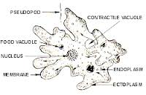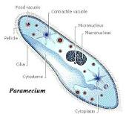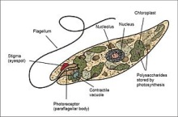



___40) What vector is most likely to carry the West Nile virus?

1. Mosquito B. mouse C. soil D. tick

___41) Which statement is true about the influenza virus?

1. Antibiotics can cure influenza
2. Influenza can be caused by a mutagen
3. Influenza can be very contagious
4. Vaccines cannot prevent influenza

___42) The diagrams show 4 DIFFERENT kinds of microbes. Which image represents bacteria?

1. 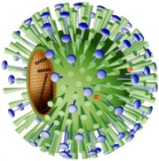1  B. 2 C. 3 D. 4



___43) The diagram shows a microbe that can cause disease. What is the significance of the structure indicated by the arrow?

1. It is pathogenic and sends toxins to the host
2. It helps the microbe attach to the cell
3. It enables the microbe to detect light and find food
4. It helps the microbe during reproduction

___44) Which disease is caused by a contagion?

1. Asthma B. cancer C. diabetes D. influenza

___45) Jake went hiking and drank water from a stream he crossed. He became ill with nausea, vomiting, and stomach cramps. Which explanation most likely describes HOW he became ill?

1. He was exposed to a mutagen form the water he drank
2. He drank water contaminated with a parasite
3. He suffered from dehydration and exhaustion
4. His stomach muscles went into lactic acid fermentation

___46) A scientist discovers a microbe with genetic material and protein, but no nucleus or cell structures. What is the best conclusion about the classification of this microbe?

1. It is a bacterium B. It is a cell C. It is a protist D. It is a virus

___47) The diagrams show 4 examples of types of microbes. Which microbe could cause **tuberculosis, a bacterial disease**?

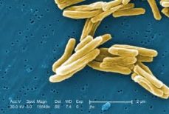A.1 B. 2 C. 3 D. 4

___48) The diagrams show 4 examples of types of microbes. Which microbe could cause **influenza, a viral infection**?

A.1 B. 2 C. 3 D. 4

___49) The diagrams show 4 examples of types of microbes. Which microbe could cause **dysentery, a protest infection**?

A.1 B. 2 C. 3 D. 4

___50) Penicillin is an antibiotic that destroys bacteria by attacking the cell wall. Which statement describes why penicillin is ineffective on viruses?

1. Penicillin helps virtues multiply
2. Viruses can use penicillin as a nutrient
3. Viruses do not have cell walls
4. Penicillin make viruses more virulent

___51) What relationship exists between a virus and a cell?

1. A cell needs a virus to obtain energy
2. A cell cannot exist without a virus
3. A virus is bigger than a cell
4. A virus needs a host to function

___52) Which microbe has both a cell wall and cytoplasm?

1. Amoeba
2. Bacterium
3. Paramecium
4. Virus

___53) The diagram shows the results of an experiment where 4 solutions were tested on the growth of bacteria. Which solution(s) can be described as having **antimicrobial** effects on the bacteria in the experiment?

|  |  |
| --- | --- |
| **Section of petri dish** | **Solution used**  2  2  1  1 |
| 1 | Alcohol |
| 2 | Ammonia  4  3  4  3 |
| 3 | Salt water  Nutrient agar with bacteria Agar with bacteria after treatment with 4 solutions |
| 4 | Bleach |

1. Alcohol and bleach B. ammonia and salt water C. alcohol only D. bleach only

___54) Which substance is beneficial to humans?

1. Antibiotic B. carcinogen C. Mutagen D. toxin