Name_________________________________________________________ Date__________________

**Unit 1: Skills of a Scientist Test Review**

Test format:

Multiple choice, including reading a graph

Matching

Graphing questions.

Dichotomous key

Create a graph.

Finding measurement.

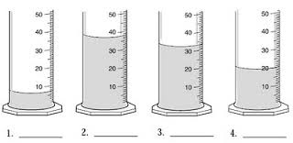

1 – 4. Find the volume of each cylinder.

1. Using Picture A, Give an example of a quantitative observation.
2. 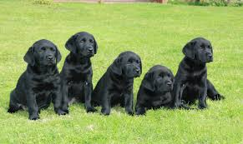Using Picture A, Give an example of a qualitative observation.

A

1. List the five steps of the Scientific Method.
2. In a controlled experiment you need to be testing one variable at a time. Describe the different parts of an experiment.

Independent variable-

Dependent variable-

Control group-

In a controlled experiment it is important to keep variables not being tested _______________ (constant, changing).

Example. You are trying to determine whether plants grow better in natural light or artificial light. You test your problem by placing 2 plants in artificial light and 2 plants in natural light. You measure their length each day for two weeks. What is the control for your experiment?

What is the independent variable?

What is the dependent variable?

Which group is the control group?

What variables should you keep constant in your experiment?

1. Find the density of an object with a mass of 132 g and a volume of 20 mL.
2. Find the volume of an object with a length of 7.2 cm, a width of 9.5 cm, and a height of 4 cm.

Define the following terms:

Observation

Inference

Temperature

Mass

Time

Density

Volume

Classify

Experiment





Be able to do the following:

1. Read a density graph
2. Create a density graph
3. Use a dichotomous key
4. Determine the independent and dependent variable of an experiment
5. Create a line graph, including labels and a title.
6. Find the mass of an object
7. Find the volume of a liquid in a graduated cylinder
8. Find the length of a line.