Water Quality Notes Pg. _______
What is water quality?

Which water do you think has the better quality? Why

Water quality is dependent on its user. Natural sources such as rivers and streams may be of good quality but not good enough for us to drink.
Quality water for wildlife includes:
Factors used to determine the quality of water in natural sources.
pH---
Selected Water Quality Standards
Substance | Limit
Arsenic | .01 parts per million (ppm)
Carbon Tetrachloride | .005 ppm
Copper | 1.3 ppm
Cyanide | .2 ppm
Lead | .015 ppm
pH | 6.5- 8.5
Turbidity--
Dissolved oxygen
Temperature--
Nitrate Levels--
Phosphate levels--
Disease causing Organisms (Coliform count)
Bioindicators--
Water to Drink
_________________________ water is necessary to sustain a human population. Though we get water from a variety of sources the water must be free of __________________________ and __________________________ _________________________ ___________________________.
Most of us get water from these two sources--- ____________________ or _______________________
Our municipal water supply comes from _________________________.
The water quality standards for drinking water is determined by what agency?

These standards limit the concentration of certain substances allowed in drinking water.
Hardness refers to the level of two elements, _________________ and ______________________, in the water. What two effects does hardness have on the water?
1.
2.
Steps in the Water Treatment Process
- _________________- Removes dirt and other particles suspended in water. Alum and other chemicals are added to water to form tiny sticky particles called "floc" which attract the dirt particles. The combined weight of the dirt and the alum (floc) become heavy enough to sink to the bottom during sedimentation.
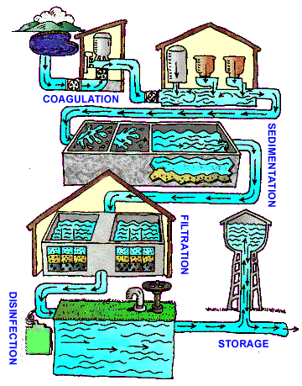
- _____________________________-The heavy particles (floc) settle to the bottom and the clear water moves to filtration.

- _________________________________---The water passes through filters, some made of layers of sand, gravel, and charcoal that help remove even smaller particles.

- ___________________________________--A small amount of chlorine is added or some other disinfection method is used to kill any bacteria or microorganisms that may be in the water.

- ________________________________---Water is placed in a closed tank or reservoir in order for disinfection to take place. The water then flows through pipes to homes and businesses in the community.

Well water does not have the same standards. It is up to the owner to have their well tested for any contaminants.

