Problem: How do I know the difference between an endothermic and an exothermic reaction?
Prediction: ____________________________________________________________________
A chemical reaction occurs when chemical bonds between atoms are broken and reformed to create a new substance. This breaking of bonds can either require or release energy. As a result chemical reactions can either release energy or absorb energy during a chemical reaction.
An endothermic reaction is a chemical reaction that absorbs energy from its surroundings so that chemical bonds can be broken. It is usually indicated by a drop or lowering in temperature. An exothermic reaction is a chemical reaction that releases energy(exo- means out) from the broken bonds. It is usually indicated by an increase in temperature.
Procedures
- Water and Calcium chloride
- Add 30 drops of water to a test tube and measure the temperature of the water with a thermometer.
- Add three(3)small scoops of Calcium Chloride (CaCl₂) to the test tube and measure the temperature.
- Observe and record any observation you made during the reaction.
- Vinegar and Baking Soda
  - Add 30 drops of vinegar to a test tube and measure the temperature of the vinegar.
  - Add three(3) small scoops of baking soda (NaHCO₃) to the test tube and measure the temperature.
  - Observe and record any observation you made during the reaction.

Data Table.
Reactants | Initial Temperature | Final Temperature | Change in temperature—Final Temp minus Initial Temperature | Observations during the reaction
Water and Calcium Chloride

Vinegar and Baking soda

- What evidence do you have as to whether a chemical reaction took place at each station?
- Was the reaction between water and calcium chloride an example of an exothermic reaction or an endothermic reaction? Explain why.
- Was the reaction between vinegar and baking soda an example of an exothermic reaction or an endothermic reaction? Explain why.
- How did the thermometer help to determine if a chemical reaction had taken place?

What is the difference between an endothermic and an exothermic reaction?
Prediction__________________________________________________________________
Data Table.
Reactants | Initial Temperature | Final Temperature | Change in temperature—Final Temp minus Initial Temperature | Observations during the reaction
Water and Calcium Chloride

Vinegar and Baking soda

- What evidence do you have as to whether a chemical reaction took place at each station?

- Was the reaction between water and calcium chloride an example of an exothermic reaction or an endothermic reaction? Explain why.

- Was the reaction between vinegar and baking soda an example of an exothermic reaction or an endothermic reaction? Explain why.

- How did the thermometer help to determine if a chemical reaction had taken place?

Intro. video
P. 74 An endothermic reaction is a chemical reaction that absorbs energy from its surroundings so that chemical bonds can be broken. It is usually indicated by a drop or lowering in temperature.
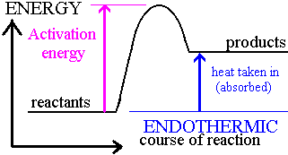

An exothermic reaction is a chemical reaction that releases energy (exo- means out) from the broken bonds. It is usually indicated by an increase in temperature.
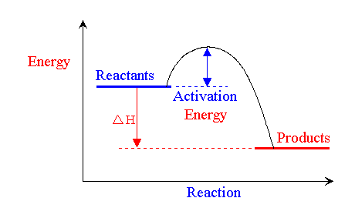

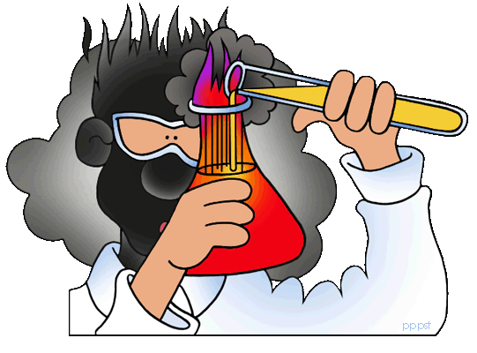
Exothermic vs. Endothermic
- A reaction that produces heat energy as a product is called __________________________.
- A reaction that absorbs energy and stores energy in the molecules of its products is __________________________________.
- When a cake bakes, the chemicals react and store energy ito the products s the cake rises. This is __________________________________.
- A match burnes so heat energy is released: _______________________________
- Wood burns in a fireplace: ___________________________
- Alka Seltzer reacts with water and the temperature drops 5 degrees Celcius. _________________________________________
- Magnesium and Hydrogen Peroxide react and the temperarure increases by 10 degrees Celcius. _____________________________________
- When an acid and a base react, the temperature increases by 15 degrees Celcius. __________________________________________
- The law of ____________________________________ of matter and energy states that matter and energy cannot be created nor destroyed. So using that law, explain what happens when wood burns. Use ideas from chemical reactions, exo or endothermic reactions and the law of conservation of mass.

