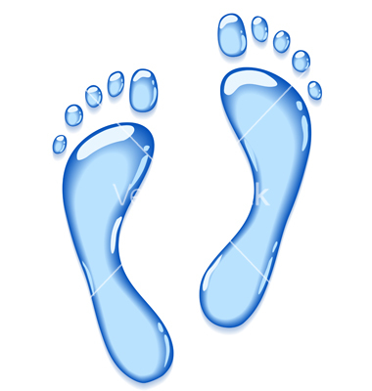
What is your water footprint?
By calculating your water footprint, you can find out how much of the world's water resources are consumed by your way of life. Even though there is still plenty of water in most of the Western countries, many of our daily products contain virtual or hidden water. Virtual water may have been consumed in countries where water is scarce. For example, one cup of coffee contains up to 140 liters of virtual water used in the production! Your water footprint reveals not only the water you use directly (in washing, for example), but also the amount of virtual water you consume.
1. Go to the following website and answer the questions about your or your family. Many of these questions may relate to your household, for example you do not own a car. Be Honest!
http://www.watercalculator.org/
2. What is your Water Footprint?
Your water footprint is: _______________________ gal/ day
Indoor water use: _______________________ gal/ day
Outdoor water use: ______________________ gal/ day
Virtual/ indirect water use: _________________ gal/day

3. In which of these do you have the most control over? Why?

4. What are two ways you can control your water use and reduce your water footprint?
Objective: Define the direct and indirect use of water. Identify ways we use water indirectly (also called virtual water) and directly.
A. Vocabulary
- Direct use of water-
- Indirect use of water-
B. Ways we may use water directly.
List as many ways you may use water directly.

C. Ways we may use water indirectly.
Water Users | How is water used by these water users? Be specific! | In what ways are you connected to these water users? Three!!!
Agriculture
Mining
Logging
Transporting/ Shipping
Business/ Industry
Wildlife
Recreation
Power Generation
Community

Use the following resources to identify information about these water users:
https://www3.epa.gov/watersense/our_water/water_use_today.html
http://www.discoverwater.org/we-all-use-water/
http://www.gracelinks.org/blog/5197/hidden-water-8-ways-we-use-water-that-might-surprise-you
Google
- Finished!! Find out how much water is used to make different items. Use the following link: http://water.usgs.gov/edu/activity-watercontent.html
- Then Find your Water Footprint. See directions on pg. ________ of your notebook.

Wildlife
How is water used by these water users? Be specific!

In what ways are you connected to these water users? Three!!!

Agriculture
How is water used by these water users? Be specific!

In what ways are you connected to these water users? Three!!!

Mining
How is water used by these water users? Be specific!

In what ways are you connected to these water users? Three!!!

Logging
How is water used by these water users? Be specific!

In what ways are you connected to these water users? Three!!!

Business
How is water used by these water users? Be specific!

In what ways are you connected to these water users? Three!!!

Transporting
How is water used by these water users? Be specific!

In what ways are you connected to these water users? Three!!!

Recreation
How is water used by these water users? Be specific!

In what ways are you connected to these water users? Three!!!

Power
How is water used by these water users? Be specific!

In what ways are you connected to these water users? Three!!!

Community
How is water used by these water users? Be specific!

In what ways are you connected to these water users? Three!!!

