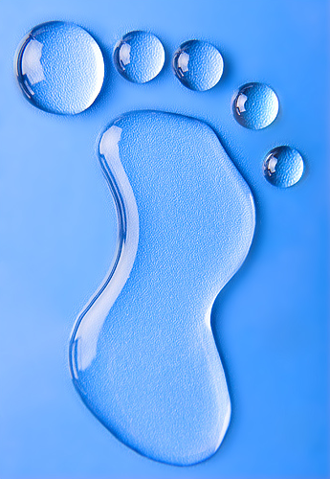
Objective: Identify ways you use water daily. Identify how we use water indirectly. Determine ways to which we can reduce our water footprint.
Background information
Your water footprint is the amount of water you use in a day and that others use to make thing you need and use daily. Your water footprint consists of two parts: direct and indirect uses of water. The direct use of water is the amount of water that you use in a day for activities such as bathing and drinking and the indirect uses include the water used by other water users that benefits you, such as water needed to irrigate (water crops) the food you eat or process the raw materials in the products you buy. What might your water footprint look like? Each individual and industry has their own water footprint.
Water is a necessary resource but not infinite resource. Water shortages occur during times of drought, overuse or misuse. It is important that we conserve our water and practice water stewardship. This is the idea that we all need water and should help to manage its use so everyone can enjoy it. This way our use of water becomes more sustainable, meaning that we can use the water and continue to have it available to us. The practice of good stewardship is the conservation of water. This may include taking shorter showers, using low flow toilets, checking for leaking faucets, and turning off the water when you are not using it. In general, we use approximately 69.3 gallons per person daily of water. How can you help to reduce the amount of water you use?
Directions.
- Think about how you use water on a daily basis. We all use water differently. On the inside of the footprint record all the ways you may use water both directly and indirectly.
- On the outside of the footprint think about how you might reduce your water footprint. Record and illustrate how you can reduce your water footprint. You can use p. 98- 99 to help you.
- Answer the following questions.
  - What is a “water footprint”?

  - What are some ways you use water every day?

  - What does “practicing good water stewardship” mean?

  - Statistics show we use approximately 69 gallons of water daily. Using the book, pp. 98- 99, list at least 4 ways we can reduce out water footprint.

  - Industry and agriculture also have a water footprint. Using the book, p. 99. What are at least 3 ways they can reduce their water footprint.

- Using the “Global Water Footprint” answer the following questions about the footprint of other countries.
  - How does this illustration define the “water footprint “of a country?

  - What is the global average footprint per year per capita?

  - According to the illustration, what percent of water is saltwater, water that is unavailable for human use? What percentage is freshwater? Remember: There are one hundred drops total.

  - What percentage of freshwater is used for irrigation (watering crops)?

  - Even foods have a footprint. Many foods require water to grow or manufacture. Which type of food has the greatest footprint?

  - The United States has one of the highest water footprints per capita per year. Why do you think this is?

